* **Image 1**

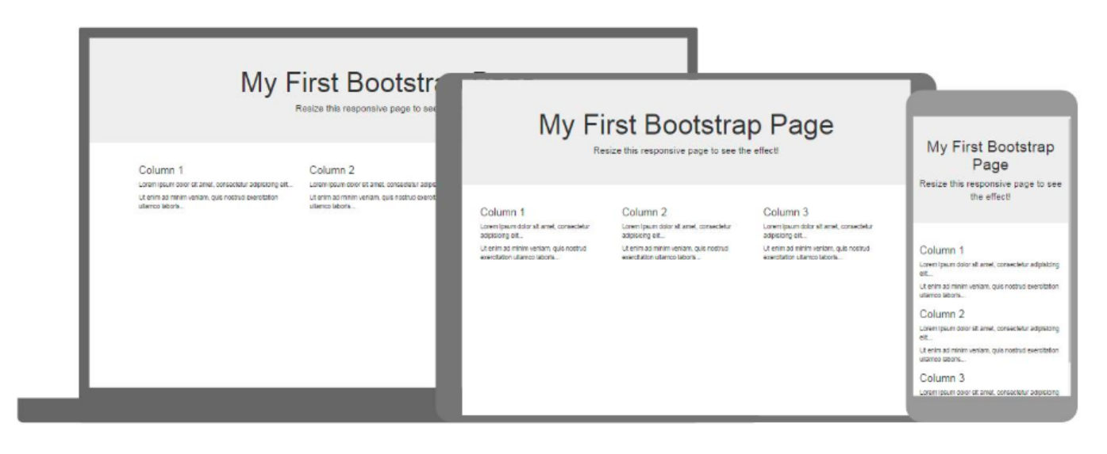

* **Explaining the div = “container”**

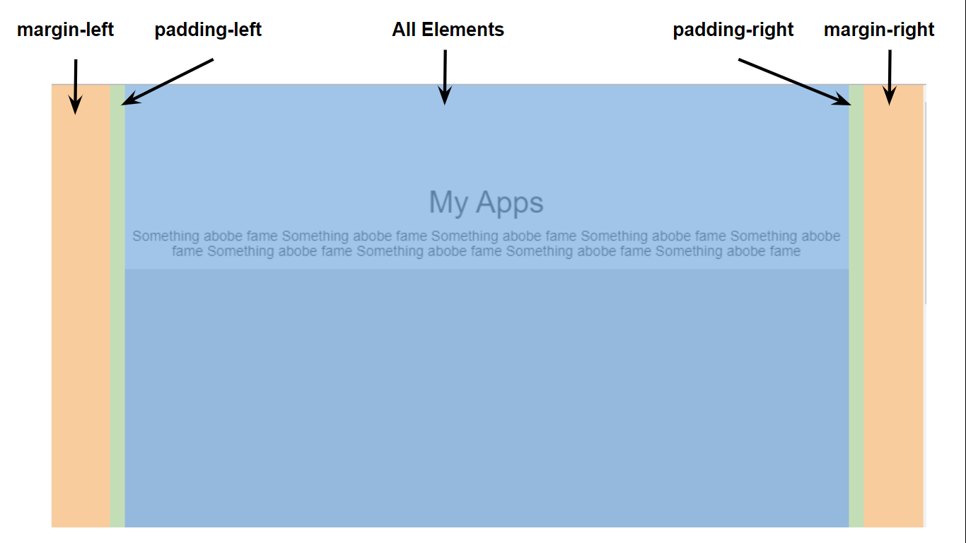

* **Code of the first section**

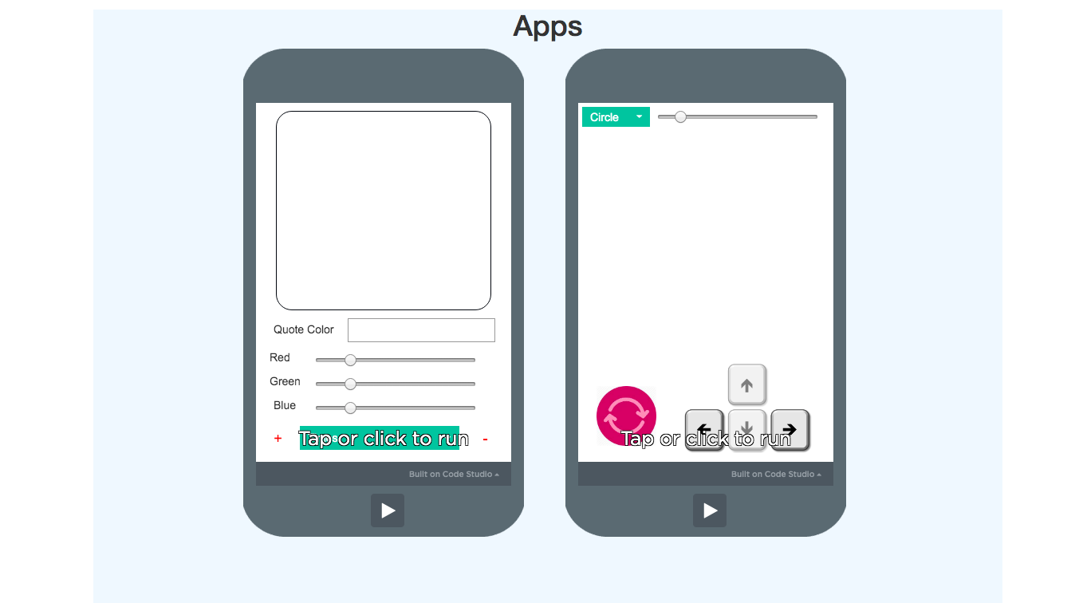

**This we have already done C60**

* **My Game Section**

**The video how the slide whoe works** [**https://drive.google.com/open?id=1MhNcKjI02asiFH65AhuoGkhm8ZKTuTad**](https://drive.google.com/open?id=1MhNcKjI02asiFH65AhuoGkhm8ZKTuTad)

* **Code of my game section**

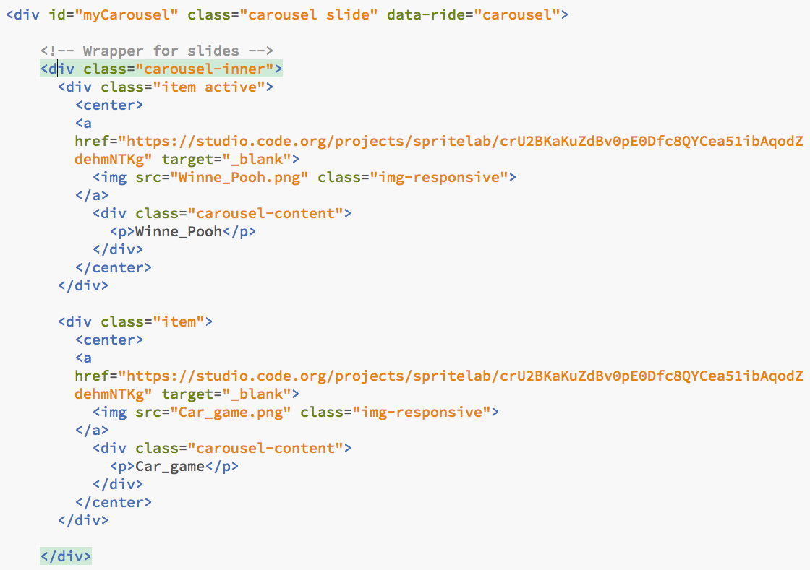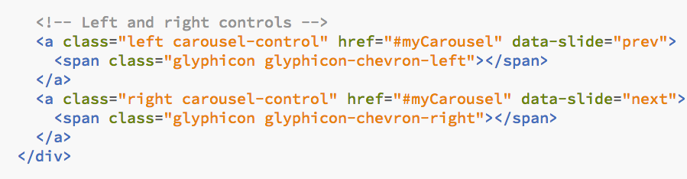

**CSS code for game section-**

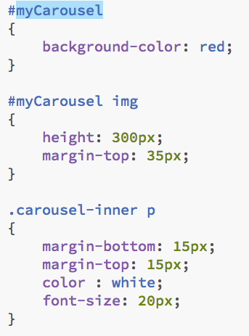

* **Code of my app section section**

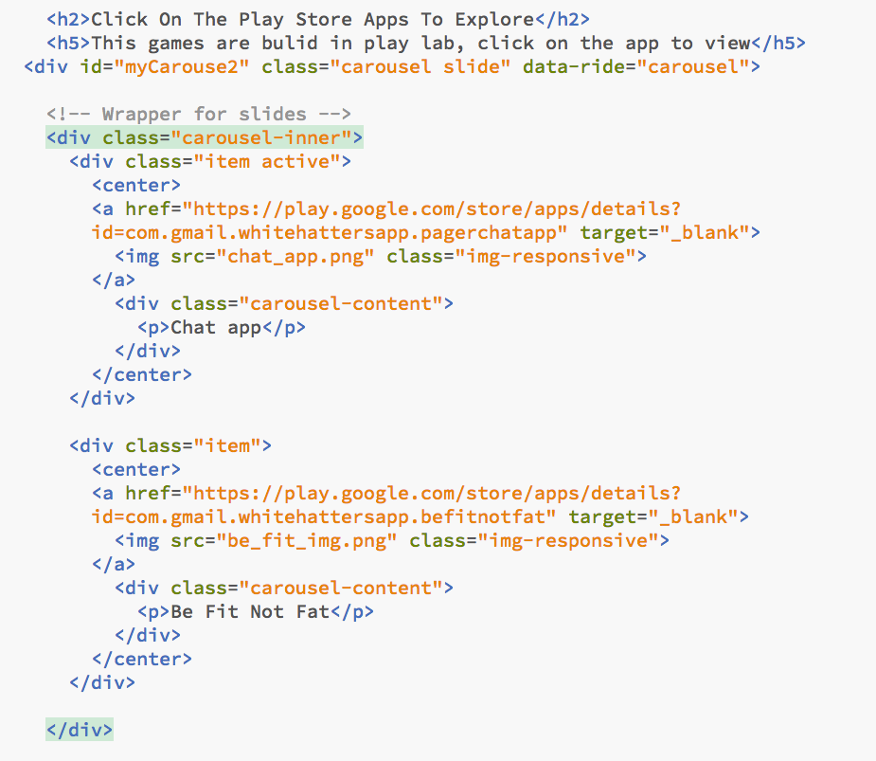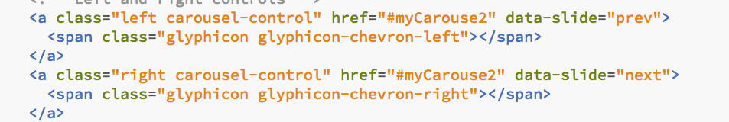

**Bootstrap classes used**

|  |  |  |
| --- | --- | --- |
| **Sr.No** | **Bootstrap classes** | **Definition(uses)** |
| **1** | **carousel** | **It specifies to the div that this div will be a carousel div** |
| **2** | **slide** | **Adds CSS animation effect** |
| **Use of the 1 & 2 class in the code -** | | |
| **3** | **carousel-inner** | **It hides all the items inside the carousel, except the active one** |
| **Use of the 3 class in the code -** | | |
| **4** | **item** | **Per images there should be a div with item class** |
| **5** | **active** | **When the page loads the div which has this class will be shown** |
| **Use of the 4 class in the code -**    **Use of the 4 & 5 class in the code -** | | |
| **6** | **img-responsive** | **This class will make the image responsive** |
| **Use of the 6 class in the code -** | | |
| **7** | **carousel-content** | **This class helps to set the text content for the content of the slider** |
| **Use of the 7 class in the code -** | | |
| **8** | **left** | **Use to set the left icon on the carousel** |
| **9** | **carousel-control** | **Sets the element that this element is the control for carousel** |
| **Use of the 8 & 9 class in the code -** | | |
| **10** | **glyphicon** | **Use to set the left icon on the carousel** |
| **11** | **glyphicon-chevron-left** | **Use to set the left icon on the carousel** |
| **Use of the 9 & 10 class in the code -** | | |
| **12** | **glyphicon-chevron-right** | **Use to set the right icon on the carousel** |